NEWSLETTER

No. 01, Term 02, Week 01

Monday 30 April 2018

Greetings, Kia ora, Talofa lava, Kia orana, Malo e lelei, Fakalofa Lahi Atu, Namaste, An Young Haseyo, Konichiwha, Bula Vinaka, Sawadee, Dobra Dan, Ni Hao, As-salamu alaykum, Hola

From the Principal – Mrs. Watts

Welcome back! We hope you had a great break and are looking forward to another term of great learning ahead.

Welcome
A big huge welcome to our new families who have started at our school. We had a Pōwhiri this morning and it was great to welcome our new whanau. We look forward to working alongside you and welcome you to our PDS whanau. We would also like to welcome Geetha Prakasm who will be the classroom teacher in Room 1 for term 2. Geetha has been a reliever at PDS.

Baking Programme and Tai Chi
This will continue as normal for term 2. If your child is involved in this, you would’ve received a newsletter about it last term.
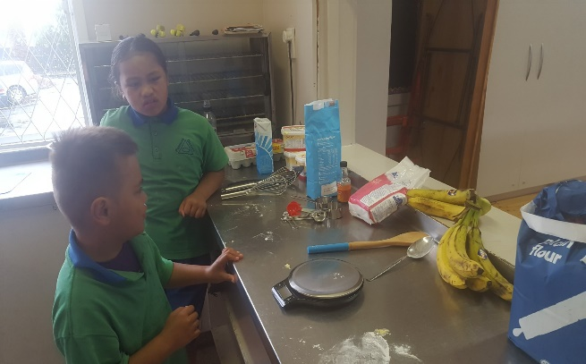

Term 2 Uniform
A reminder that winter uniform is to be worn this term. There are both second hand ($5-$15) and new jumpers ($42) available at the school office.

Room 2
It would be great if parents or siblings of children in Room 2 are picked up from their classroom. This will also give parents a chance to talk to Mrs Kumar about your child’s learning.

ASB Banking
We can now offer school banking. Banking day is on Friday. Forms are located on the Kashin the Elephant bank deposit box in our reception area. When children sign up to open an ASB account, they will be sent a Kashin deposit box and calculator in a yellow bag - all to keep. If you’d like to register your child for free, for this, please see our friendly office staff.
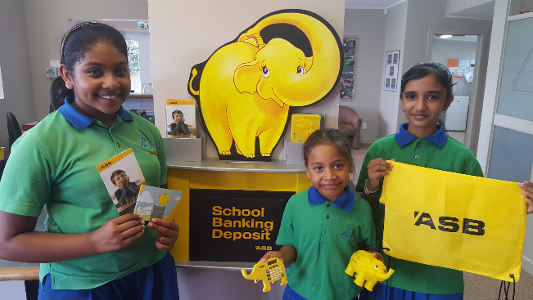

Winning House
Congratulations to our house winner - PURIRI who won on the last week of school.
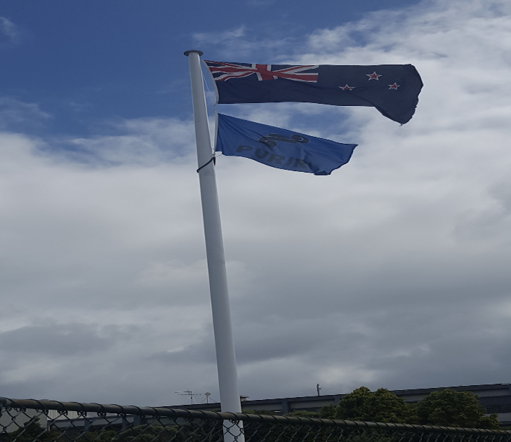

Term 2 upcoming dates
Festival of Cultural Sharing temple Visit on Thursday 10 May.
Tamaki Cluster Football for Year 5/6 and Year 7/8
Dental Van visit in week 04.
Auckland University Optometry eye testing on 24 May in the school hall.

